# **Sponsored Product Ads – Campaign Structure & Strategy SOP**

## **Objective**

This SOP defines the structured approach to creating, organizing, and optimizing Sponsored Product (SP) campaigns on Amazon. The strategy is designed to cover all key areas — brand defense, discovery, competitor targeting, ranking, and conversion optimization — ensuring complete funnel coverage for maximum visibility, sales, and profitability.

## **Phase 01 – Launch & Discovery**

### **1.1 Branded Defensive Campaigns**

#### **Objective**

* Protect branded search terms from competitor ads.
* Capture high-intent shoppers already searching for the brand.
* Ensure brand dominance on Top of Search placements.

#### **Campaign Naming Convention**

PN-Defensive-BrandedKWs-TOS-Date

#### **Targeting & Structure**

* Manual Targeting: **Exact, Phrase, Broad Matches**
* Focus Placement: **Top of Search**
* Bidding Strategy: **Fixed Bids**

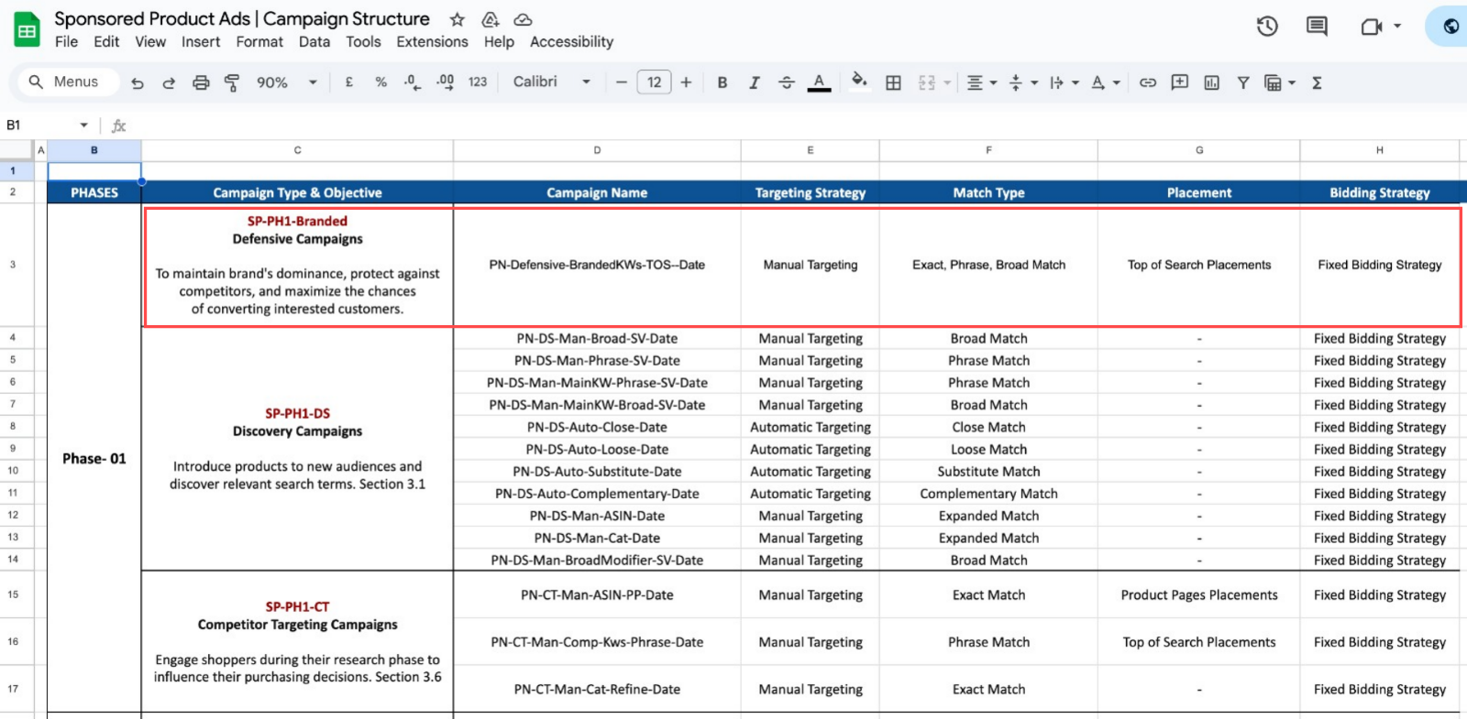

### **1.2 Discovery Campaigns**

#### **Objective**

* Discover new relevant search terms.
* Expand product visibility to broader audiences.
* Identify new keywords for future ranking & optimization.

#### **Campaign Naming Convention**

| **Campaign Type** | **Naming Convention** |
| --- | --- |
| Manual Broad | PN-DS-Man-Broad-SV-Date |
| Manual Phrase | PN-DS-Man-Phrase-SV-Date |
| Main KW Phrase | PN-DS-Man-MainKW-Phrase-SV-Date |
| Main KW Broad | PN-DS-Man-MainKW-Broad-SV-Date |
| Auto Close Match | PN-DS-Auto-Close-Date |
| Auto Loose Match | PN-DS-Auto-Loose-Date |
| Auto Substitute | PN-DS-Auto-Substitute-Date |
| Auto Complementary | PN-DS-Auto-Complementary-Date |
| ASIN Targeting | PN-DS-Man-ASIN-Date |
| Category Targeting | PN-DS-Man-Cat-Date |
| Broad Modifier | PN-DS-Man-BroadModifier-SV-Date |

#### **Targeting & Structure**

* Mix of **Manual & Automatic Targeting**.
* Match Types: **Broad, Phrase, Exact (for main keywords)**.
* Automatic Targets: **Close, Loose, Substitute, Complementary**.
* Bidding Strategy: **Fixed Bids**.

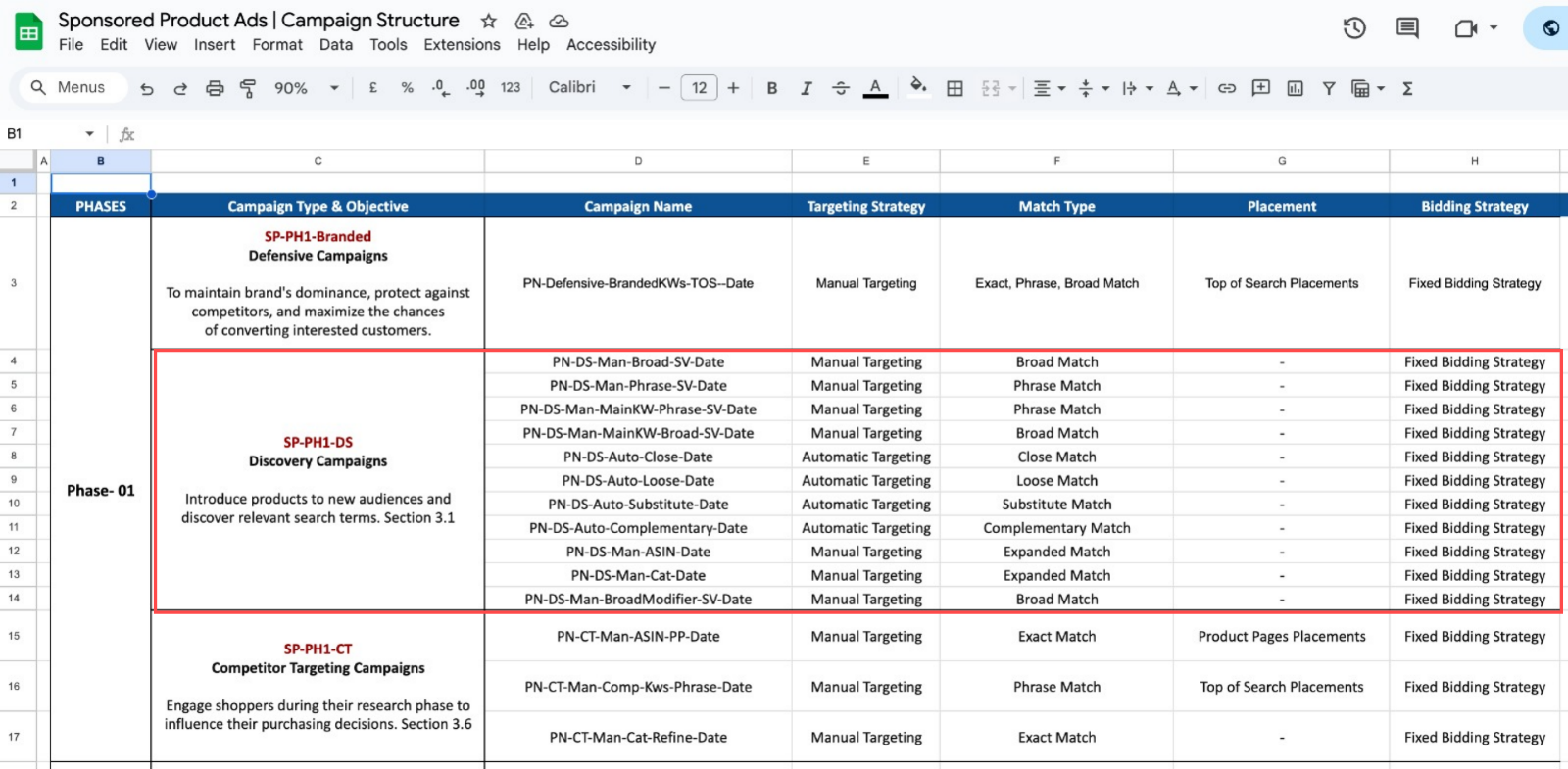

### **1.3 Competitor Targeting Campaigns**

#### **Objective**

* Capture competitor traffic by appearing on competitor product pages.
* Influence shoppers during product comparison.
* Drive consideration and potential switches.

#### **Campaign Naming Convention**

| **Campaign Type** | **Naming Convention** |
| --- | --- |
| ASIN Targeting (Product Page Focus) | PN-CT-Man-ASIN-PP-Date |
| Competitor KWs (Top of Search Focus) | PN-CT-Man-Comp-Kws-Phrase-Date |
| Category Refined Targeting | PN-CT-Man-Cat-Refine-Date |

#### **Targeting & Structure**

* Manual Targeting: **ASIN, Category, Competitor Keywords**.
* Placements: **Top of Search & Product Pages**.
* Match Types: **Exact, Phrase**.
* Bidding Strategy: **Fixed Bids**.

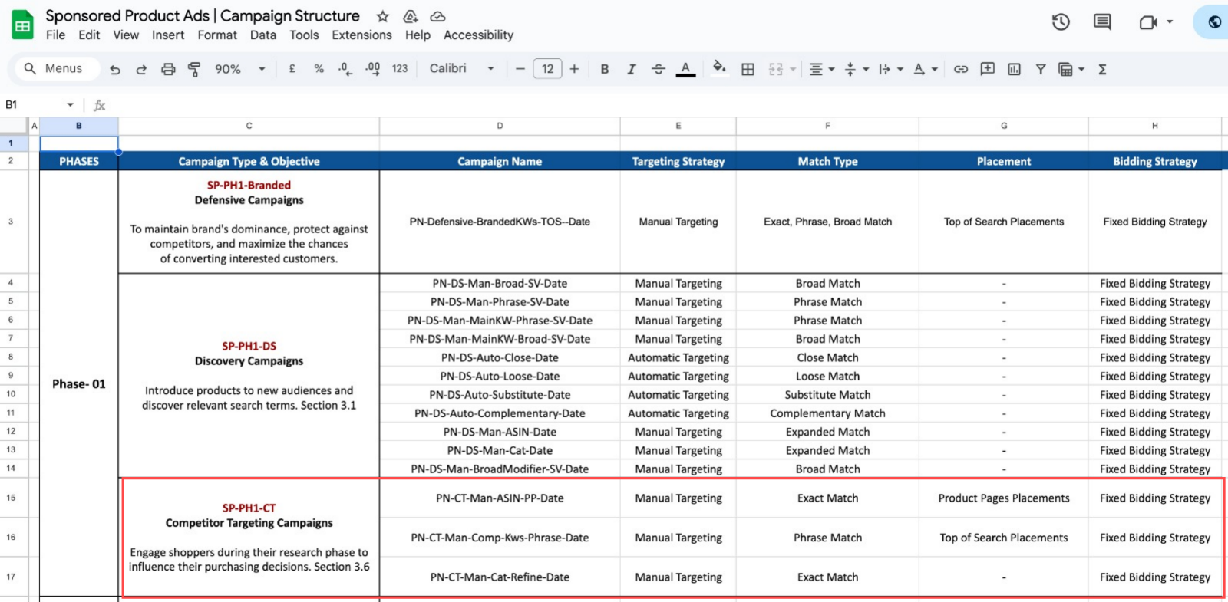

## **Phase 02 – Ranking Focus**

### **2.1 Ranking Campaigns**

#### **Objective**

* Focus ad spend on high-priority keywords to boost organic ranking.
* Drive aggressive visibility for selected search terms critical for success.

#### **Campaign Naming Convention**

PN-Rank-Man-MainKW-Exact-SV-Date

#### **Targeting & Structure**

* Manual Targeting: **Exact Match** only.
* Focus Placement: **Top of Search**.
* Bidding Strategy: **Fixed Bids**.
* Focus Keywords: Top converting terms from Phase 01.

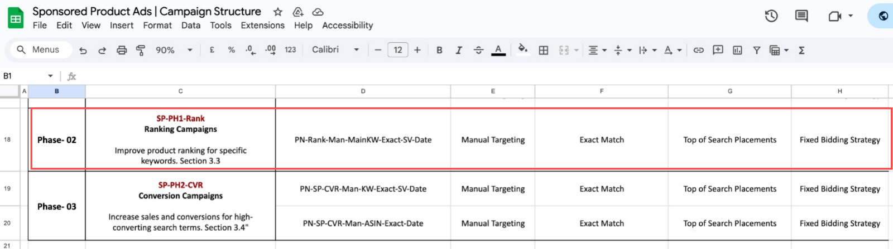

## **Phase 03 – Conversion Optimization**

### **3.1 Conversion Campaigns (High Converting Keywords & ASINs)**

#### **Objective**

* Maximize conversions from proven, high-converting keywords & ASINs.
* Optimize for profitability after discovery & ranking phases.

#### **Campaign Naming Convention**

| **Campaign Type** | **Naming Convention** |
| --- | --- |
| High-Converting Keywords | PN-SP-CVR-Man-KW-Exact-SV-Date |
| High-Converting ASINs | PN-SP-CVR-Man-ASIN-Exact-Date |

#### **Targeting & Structure**

* Manual Targeting: **Exact Match** only.
* Focus Placement: **Top of Search**.
* Bidding Strategy: **Fixed Bids**.
* Focus Terms: Keywords and ASINs with best historical conversion rates.

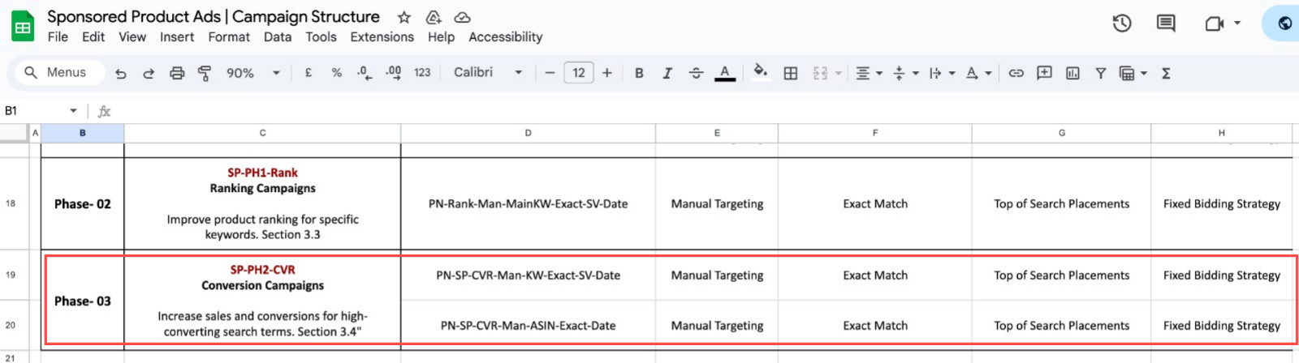

Detailed Campaign Structure Template  
[Sponsored Product Ads | Campaign Structure](https://docs.google.com/spreadsheets/d/1H5FnmVHOHP4XoA0559cpjv_bC3QgrJc5XVdvYYRfuro/edit?gid=1782950721#gid=1782950721)

## **General Rules Across All Phases**

| **Element** | **Rule/Best Practice** |
| --- | --- |
| Naming Consistency | Use the defined naming conventions to allow clear tracking & easy reporting. |
| Budget Allocation | Higher for Phase 01 (Discovery), Balanced for Phase 02 (Ranking), Profit Focused in Phase 03 (Conversion). |
| Keyword Harvesting | Constantly move high-performing keywords from discovery to ranking/conversion campaigns. |
| Negative Targeting | Add irrelevant or low-converting terms as negatives weekly. |
| Bid Strategy | Default to Fixed Bids, review bid adjustments weekly based on data. |
| Placement Focus | Top of Search for branded, ranking & conversion campaigns. Mixed placements for discovery & competitor campaigns. |
| Data Review Frequency | Weekly data review for bid optimization, keyword promotion, and ASIN/category refinement. |